Registration Form:Desktop Application
1 .Registration Icon for Desktop Application

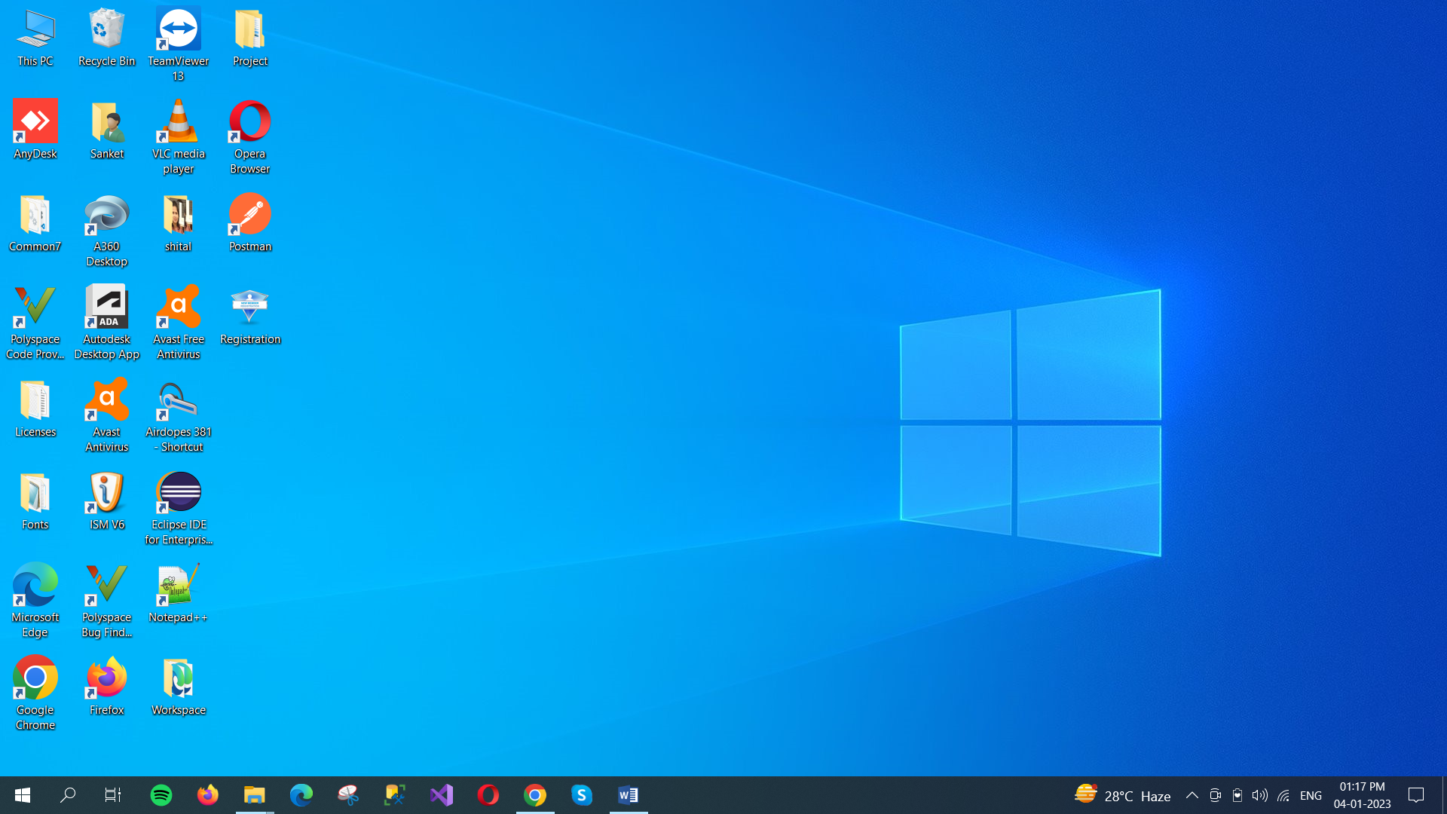
This Icon is Created on Desktop

2.After Click On this:
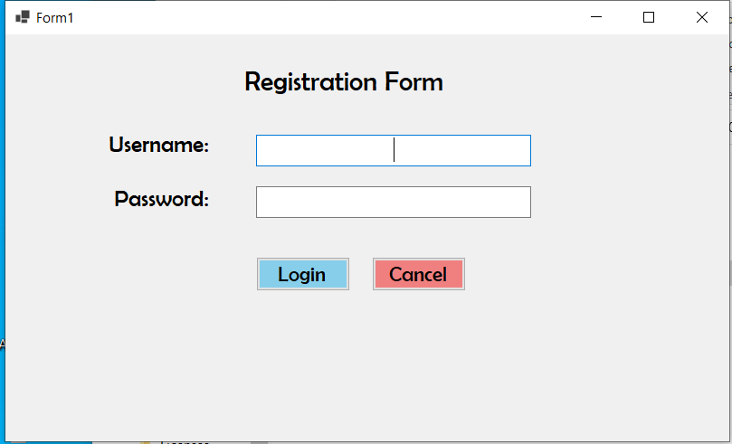

2.Login Successfully & Second Page Open
Username:Abbvie
Password:AbbVie
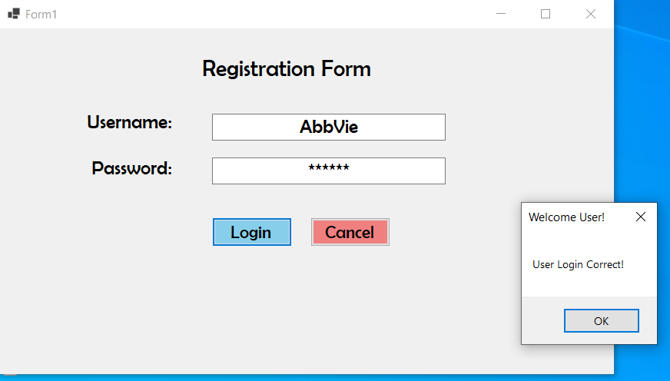



3 .Login Failed
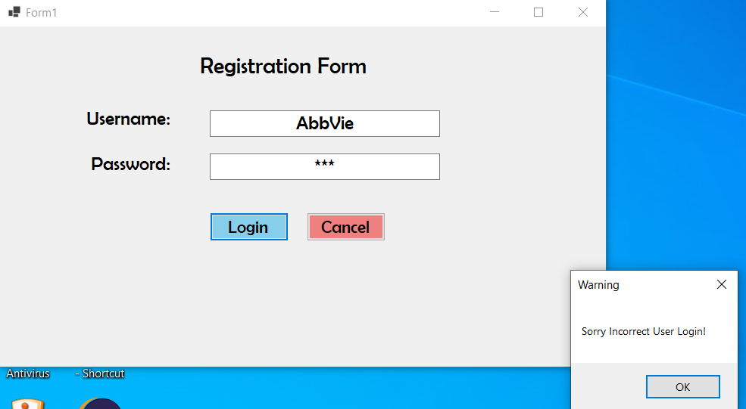

4. After clicking on Cancel Close that Application

